User Guide 34 Testing your digital certificate

Purpose of this Guide

The purpose of this guide is to assist you in testing your digital certificate for use in SPEAR.

34.1 How do I test my digital certificate?

1. Please ensure you have installed and backed up your digital certificates. For more information see User Guide 33 – Installing and backing up your digital certificates.
2. Contact the SPEAR Service Desk on 9194 0612 if you do not have a SPEAR login ID and password.
3. Login to SPEAR via the SPEAR homepage [www.spear.land.vic.gov.au/spear/](https://www.spear.land.vic.gov.au/spear/)
4. If you have not yet tested a digital certificate in SPEAR, you will automatically be prompted to do so when you login to SPEAR (see step 6).
5. If you have already tested your certificate in SPEAR, and want to test it again, then you will need to click on the Settings link at the top of your SPEAR screen.

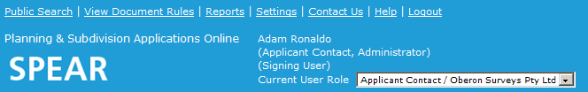

From the Settings screen, scroll down to the bottom of the page and click on the Test Digital Certificate link.

1. Click the ‘test’ button to begin.

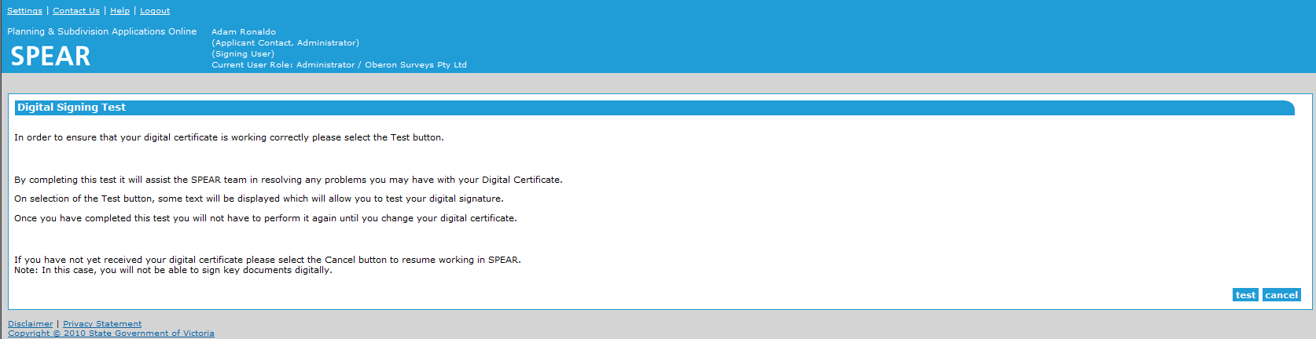

1. Click ‘save’ and then ‘open’.

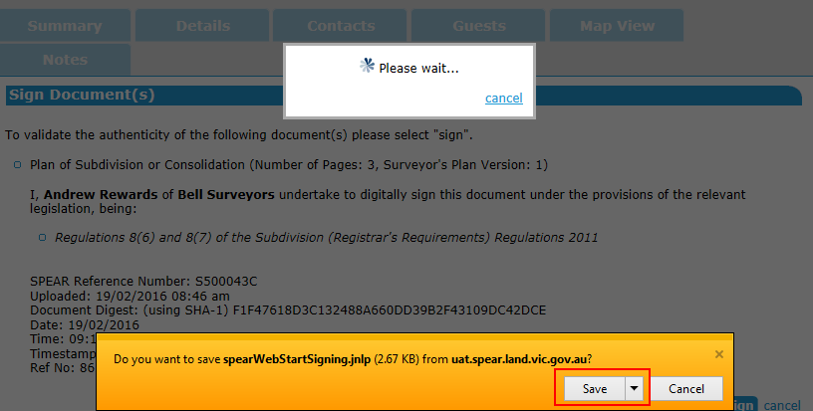

**NOTE: Depending on the browser you are using, you may be prompted to choose a location to save the file, or it will save to the default download folder. This is a single use signing file, which you will be required to save, each time you sign. These files can be deleted once signing has been performed.**

1. The selected certificate details are displayed. Click ‘sign’ .

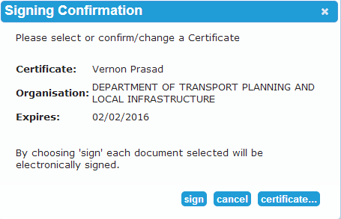

1. The password window will pop up. Enter your certificate password and click ‘ok’.

**NOTE:** **In some versions of Windows, the password window will pop up behind your web browser. If this is the case, you will need to click the Java icon on your taskbar to open the password window.**

1. A confirmation screen will be displayed if signing was successful. You can now begin using SPEAR.

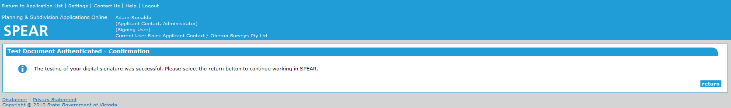

If you received an error or you were not prompted for a password, please contact the SPEAR Service Desk on 9194 0612.

Need more information?

Further information on this topic can be found by:

* Visiting the SPEAR website [www.spear.land.vic.gov.au/SPEAR](http://www.spear.land.vic.gov.au/SPEAR).
* Contacting the SPEAR Service Desk on 9194 0612 or email [spear.info@delwp.vic.gov.au](mailto:spear.info@delwp.vic.gov.au)